Maryland Restorative Justice Initiative Monthly Newsletter
Volume 3, Issue 3
March 2012

Quote of the month: When life throws you a curve, as it invariably will, (don’t duck) step back, reassess, adjust your position and strategy, and step back up to the plate with renewed vigor and determination.

Legislative Update:
By Walter Lomax
Maryland Gov. O’Malley’s recent decision to consider releasing Ms. Settle and Mr. Farley shows he has taken seriously a mass effort to reform the laws governing parole-eligible life sentences. Advocates have been challenging for years the flawed logic that a figure as political as the Governor must give the stamp of approval to the Parole Commission’s decisions, and last year we saw a small victory when legislation was passed to limit the time the governor has to overturn a parole decision to 180 days. However, the possible release of these two people doesn’t set aside the larger issue that the other fifty-plus “lifers” who were recommended for parole remain indefinitely behind bars, for no reason besides politics.

With his current announcement, Governor O’Malley is acting on two clear cases of injustice. Having been the victim of injustice myself, and imprisoned for close to 40 years for a crime I did not commit, I understand the importance of addressing such injustices and know how much it means to the people being considered and their families. Mr. Farley, only 14 when convicted of a crime that the only witness later said he did not commit, and Ms. Settle, who has already served three times as long as the person involved in the same case who pulled the trigger, both should have been released years ago. It was the necessity for the Governor’s approval after the Parole Commission’s recommendation that has kept them behind bars.
While there may be other cases of innocence, other cases of overly harsh sentences, among the remaining cases sitting on the governor’s desk, the fact is that all the other people who have been recommended for parole should have been released. That only these particular two cases are being considered means there is clearly still a need for current legislative proposals that would take the governor out of the parole process.
The core issue behind last year’s legislation and this year’s bills SB-584 & 492 is that all of the people given sentences of life with the possibility of parole were told, and believed, they would have a meaningful chance of going home if they had good behavior in prison, made serious efforts to rehabilitate themselves, and accepted responsibility and were remorse for the harm they caused. And the Maryland Parole Commission has taken seriously their responsibility to recommend only the people they feel won’t jeopardize public safety and are most likely to be successful when they reenter the community. That only 53 out of 2,500 people serving parole-eligible life sentences have been recommended for release shows the Commission is being conservative and thoughtful, and their decisions should stand.

I have been working on this issue since my release in 2006 because there are many people who have been in prison for decades who would be an asset to their families and communities if released. As it is, any hope that they have had, any incentive that the possibility of parole has provided them to better themselves and become a positive impact in prison has been stripped from them.

The two people being considered for release now represent the two categories of “lifers” that this year’s bills would exempt from the governor’s veto: those who were juveniles at the time of the offense, and those who were accessories, not principals, in the crime. There are many people who received parole-eligible life sentences who made a bad decision to be involved in a crime, but who never killed or intended to kill anyone. To keep them locked up forever is just not right. And for those who were children at the time they were sent to prison, being sentenced to die in prison is a policy virtually all countries in the world have rejected.

It was one year ago during a rally at the Capitol that Gov. Martin O’Malley mirrored his predecessor’s words and told TV cameras “life means life.” Former Gov. Glendenning has since taken those words back and stated that he no longer supported policies that did not allow parole consideration for people serving eligible life sentences. That the Governor is willing to consider approving the Parole Commission’s decision in two cases of clear injustice is a step in the right direction. But it is our hope the legislature will consider the broader injustice that is created when we allow politics to usurp the parole process.

Walter Lomax is the executive director of the Maryland Restorative Justice Initiative.

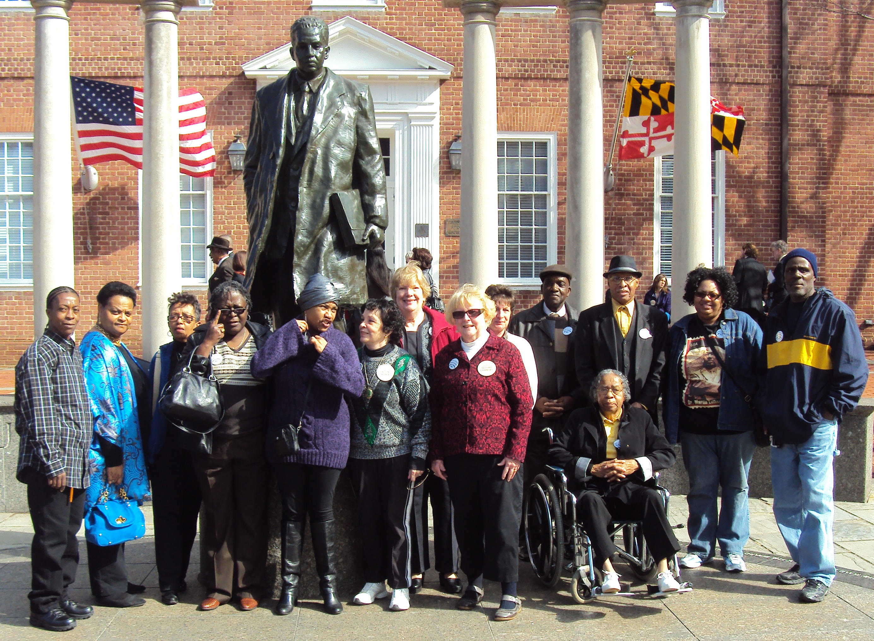
Jessup Region:

JCI: Wayne Brewton, 17 when incarcerated in 1979, has been incarcerated 33 years, is current 50 years old, Donald Young, 16 when incarcerated in 1983, has been incarcerated 28 years, and is currently 44 years old, Karl D. Brown, 17 when incarcerated in 1976, has been incarcerated 35 years, and is currently 52 years old, Norman A. Ayers, 15 when incarcerated 1970, has been incarcerated 41 years is currently 57 years old, Mr. Robert Boyd 16 when incarcerated 1982, has been incarcerated 30 years, is currently 46 years old,

MCI-J:

MCI-W:
Shawnte Perry 15 when incarcerated in 1995, has been incarcerated 17 years, is currently 32 years old,
Towanda Jones 15 when incarcerated in 1988, has been incarcerated 24 years, is currently 39 years old.

Hagerstown Region:

MCTC:
Brian Tate 16 when incarcerated 1992, has been incarcerated 19 years, is currently 35 years old.

MCI-H:
Neal T. Cohen, 16 when incarcerated in 1978, has been incarcerated 33 years, is currently 50 years old, Mark F. Grant, 14 when incarcerated in 1983, has been incarcerated 28 years, and is currently 42 years old, Michael Ringgold, 15 when incarcerated in 1993, has been incarcerated 18 years, and is currently 33 years old, Glenn Jones, 15 when incarcerated 1981, has been incarcerated 30 years, is currently 46 years old, Mr. Gary Lee Miller 16 when incarcerated 1967, has been incarcerated 45 years, is currently 61 years old, Mr. Michael Crawson 16 when incarcerated 1993 has been incarcerated 17 years, is currently 33 years old, Alonzo E. Turner-Bey 17 when incarcerated 1989, has been incarcerated 23 years, is currently 40 years old, MCI-H is sponsoring a Legal symposium April 19, 2012.

RCI:

Mr. William A. Gardner 16 when incarcerated 1968, has been incarcerated, has been incarcerated 44 years, is currently 59 years old, Mr. Gordon Pack 15 when incarcerated 1979, has been incarcerated 32 years, is currently 48 years old, RCI is sponsoring a Legal Seminar March 21, 2012.

Cumberland Region:
WCI:
John H. Ristick Donald Braxton, 16 when incarcerated, has been incarcerated 29 years, is currently 45 years old, Baron Brock, 16 when incarcerated in 1992, has been incarcerated 19 years, is currently 35 years old, Mr. 15 when incarcerated 1985, has been incarcerated 27 years, is currently 42 years old,

NBCI:

Easton Shore Region:

ECI:
Robert Martin, 15 when incarcerated in 1976, has been incarcerated 35 years, and is currently 50 years old, Erin P. Timmons 17 when incarcerated 1993, has been incarcerated 20 years, is currently 37 years old,

Patuxent:
Michael Evens, 16 when incarcerated in 1978, has been incarcerated 33 years, will be 50 February, John A. Jones, 17 when incarcerated, 1983, has been incarcerated 28 years is currently 45 years old, Donald E. Scaggs, 17 when incarcerated 1987, has been incarcerated 25 years, is currently 42 years old, Arthur Miles 16 when incarcerated 1990, Hs been incarcerated 22 years, is currently 38 years old

General News: Some of the people who signed on to testified at the hearings. 3/1/2012: Lionel Williams & his Uncle, Pamela Beal, Barbara Wilson, Fatima Cook, Betty May, Sheik Alexander Prather-EL & his Father, Mary Brown-Bey, Susan Eberhard, Mary Pat Donelan, Ed Sabin, Gail Evans, Laura Washington, Scott Adams, Jeffery Gresham, Brenda Flower, Tammy Blackmon, Melissa Goermann Maryland Legislative Director for the ACLU, Tracy Velazquez Director at JPI, Merle Morrow, Corrine Stanley, Lea Green, CURE, Linda Clarke, Mr. & Mrs. Arthur Timmins Ruth Jones, Kay Starks, Art & Rita Tate, Barbara J. Wilson, Shanisa Jones.

MRJI is a program of Fusion Partnership Inc. Supported in part by a grant from Baltimore OSI


